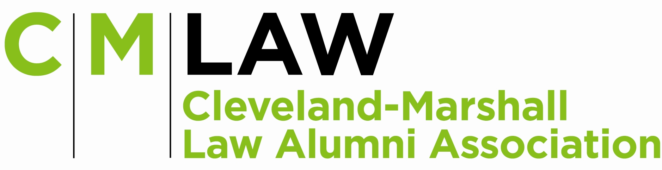

C|M|LAW ALUMNI ASSOCIATION

BAR EXAM REVIEW SCHOLARSHIP PROGRAM

The C|M|LAW Alumni Association’s Bar Exam Scholarship Fund was established in 2009 to aid worthy C|M|LAW students, in their final year, to attend a bar review course prior to taking the bar exam.

A maximum of ten (10) scholarships will be awarded to students of C|M|LAW for the 2012 Bar Exams. Each scholarship will be comprised of a credit of $1,000 towards the purchase of the bar review exam course offered by BARBRI. The scholarship will be awarded in the form of a credit to the overall cost of the course with no monetary value. The scholarship cannot be combined with another BARBRI scholarship.

The scholarships may be awarded to any student in good standing who is in his/her final year of study at C|M|LAW.

The C|M|LAW Alumni Association, through its Student Relations/Professional Opportunities Committee, will determine the recipients of the scholarship grants. The Association will take into consideration:

- Scholastic achievement in law school
- Financial need
- Employment

The above criteria have been established as a guideline for the award of a scholarship. Other factors may also be considered, at the sole discretion of the Student Relations/ Professional Opportunities Committee.

All applicants are required to complete the application in its entirety. The application must be typed and signed.

If a student is taking the July ‘12 Bar Exam, the scholarship application deadline is February 20, 2012. An email will notify each recipient, no later than March 1, 2012 that he/she has been awarded a scholarship.
C|M|LAW ALUMNI ASSOCIATION
BAR REVIEW SCHOLARSHIP APPLICATION

Instructions:

- APPLICATION MUST BE TYPED.
- ALL QUESTIONS MUST BE COMPLETED IN ORDER FOR YOUR APPLICATION TO BE CONSIDERED. NOTE: SPELLING, GRAMMAR AND PUNCTUATION WILL BE TAKEN INTO CONSIDERATION.
- FOR STUDENTS TAKING THE JULY ‘12 BAR EXAM, COMPLETED APPLICATION MUST BE RECEIVED IN THE ALUMNI OFFICE (LB #121) BY FEBRUARY 20, 2012.

1. Full Name
(Last) (First) (Middle)

Anticipated Date of Graduation: May 2012 ______

2. Present Mailing Address
Street City

State Zip Code Telephone

3. Permanent Address
Street City

State Zip Code Telephone

4. List all colleges and graduate schools attended:

Institution Date of Attendance Degree Date Awarded

a)

b)

c)

d)

5. List all undergraduate college scholastic honors received:

6. Your current employer:

Name

Address Telephone

Position:

Number of hours worked weekly:

7. Name of spouse, if any:

8. Spouse’s occupation:

Full Time: Part Time:

9. Name of Dependents Relationship Age

a)

b)

c)

d)

10. Why do you feel you should be awarded a scholarship?

11. List your current GPA:

12. Class Rank No. of in class.

13. Applicant has taken (or will take) all required steps, including the character and fitness certification, necessary for taking the bar examination immediately following graduation:

Yes _____ No _____

14. If you have accepted or are considering an offer of employment after graduation from CM, please provide the following information:

Name of the employer: ____________________________________________

Anticipated start date: _________________

Will the employer pay for a bar review course or provide a stipend for bar exam preparation?

Yes ____ No ____ N/A ______

The scholarship cannot be combined with another BARBRI scholarship.
AUTHORIZATION and CERTIFICATION

I HEREBY AUTHORIZE the C|M|LAW Alumni Association and its Student Relations/Professional Opportunities Committee to obtain any and all records from C|M|LAW and Cleveland State University, which it may in its sole discretion need to verify any information in this application. The Law Alumni Association and its Student Relations/Professional Opportunities Committee shall maintain any and all information obtained in strict confidence and will use solely for the determination of eligibility for the bar exam scholarship. I agree that the C|M|LAW Alumni Association and its Student Relations/Professional Opportunities Committee shall have, and reserves, the right to revoke a scholarship at any time if in its discretion it learns that any of the information provided herein is incorrect or that the applicant’s status has changed after the award of the scholarship. I further certify that the information contained in my application is accurate and complete to the best of my knowledge.

Signature of Applicant Date

Students taking the July ’12 Bar Exam: application due February 20, 2012.

RETURN COMPLETED & SIGNED APPLICATION TO:

C|M|LAW Alumni Association
Mary McKenna, Executive Director
Bob Walton, Michelle DeBaltzo, Brendan Doyle, Co-Chairs, Student Relations/Professional Opportunities Committee
2121 Euclid Avenue – LB 121
Cleveland, Ohio 44115

Phone: 216.687.2368
mary.mckenna@law.csuohio.edu

