_____________________________________________________________________________

COURSE INFORMATION

Instructor
Instructor: Heidi Gorovitz Robertson, J.D., LL.M, J.S.D.,
Steven W. Percy Professor of Law, College of Law
Professor of Environmental Studies, Levin College of Education/Public Affairs
Email: H.Robertson@csuohio.edu
Office: LB130 (near the Faculty/Staff Lounge, just off the atrium)
Phone: Don’t bother with the office phone– please use email instead.
Office Hours: 3:00 p.m.-4:00 p.m. on Tuesdays and Thursdays, and by appointment via my Bookings page at Book time with Heidi G Robertson

Course Meetings
Please refer to the course schedule for alterations.
Section 1: Tuesday/Thursday 1:00 p.m. to 2:40 p.m.
Section 2: Tuesday/Thursday 10:00 a.m. to 11:40 a.m.

Textbook/Course Materials

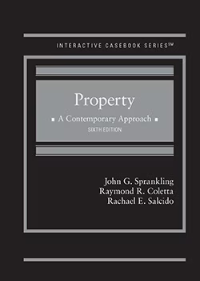

The primary text for this course will be Property – A Contemporary Approach, 6th Ed., by John G. Sprankling, Raymond R. Coletta, and Rachael Salcido (West). NOTE: If you choose to use a different edition, that’s OK, but you will be entirely responsible for identifying, on your own, any differences in page numbers, sections, substance, and for reading the assigned material in preparation for class.
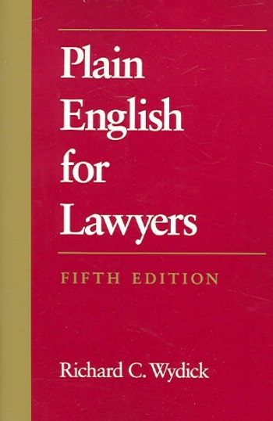

Writing skills will be important for this course. I recommend that you buy or borrow a copy of PLAIN ENGLISH FOR LAWYERS, by Richard C. Wydick (Carolina Academic Press). Any edition is fine. Read it carefully before you take an examination or write anything at all for this class. It is available used, through Amazon, for as little as $1.00. If you have questions about anything in this book, please come chat with me about it. I am here to help – with no judgment. I promise.

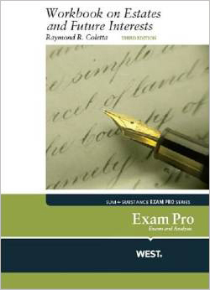

For the estates in land portion of the course, we’ll use Colletta’s Exam Pro Workbook on Estates and Future Interests, 3d edition.

HINT: I take all questions for the mid-term exam on estates in land and future interests straight from the practice exercises in this book, or from the main Sprankling book or from my class handouts, which will be posted on Blackboard. (Of course, I change the names and conditions to make them much more fun!)

Course Management System
Please make friends with the Blackboard site for this course. I will use it for lots of things – posting handouts, taking polls, sending messages and announcements, administering quizzes, etc. NOTE: The Modules on Blackboard are not required. I created them to support the readings for JDO students. You may use them if you find them helpful.

Course Description
The course will explore the law regulating the rights of private property. We will consider why we call some resources property, how we allocate those resources, why we regulate an owner’s use of a resource, and the strategies we use to maximize the economic value of resources. We will cover both theory and doctrine addressing ownership, possession and transfer of real and personal property. Aspects of property law that are covered include discovery, creation, capture, the estates system, landlord-tenant law, adverse possession, transfers of land, private and public law systems for regulating land use (including easements, covenants, zoning and eminent domain) and the constitutional protections of property.

Course Goals & Learning Objectives

GOALS | OBJECTIVES | ASSESSMENTS
Upon successful completion of this course, students will know/understand: | Upon successful completion of this course, students will be able to: | The student will be assessed on these learning objectives though:
Understand basic principles of Property Law as in course description | Articulate and apply basic principles of property law | Class participation, practice exam, midterms, final exam
Understand principles of basic written legal analysis | Consistently execute basic legal analysis both orally and in writing | Class participation, practice exam, midterms, final exam
Experience multiple forms of assessment | Show improvement both in essay exams and multiple-choice questions | Class participation, practice exam, midterms, final exam

Assignments/Exams/Evaluation/Grading
You will have a practice exam/exercise partway through the semester. We will ‘grade’ it together, though your score on the practice exam/exercise will not count towards your course grade. Its purpose is to help you improve exam performance before the midterms and final.

After the practice exam, you will have two midterm exams that will count towards your final course grade. The idea is that you’ll have learned enough on the practice exam to do better on the exams that count! One midterm will assess your understanding of the basic property law principles covered up to the midterm, and the other will focus on estates in land and future interests.

In addition, you will have regular, in-class multiple-choice quizzes throughout the semester as we finish sections of material. These will help you with the multiple-choice assessment format and with understanding what you know and what you don’t know concerning the substance of the course. Although these quizzes will not count towards your course grade, they are useful to help you and me see what you’re understanding and where you need assistance.

All exams in this course will be CLOSED book. They will be both word count-limited and time-limited.

I will weigh your scores as follows:

Attendance, Participation & Preparedness 10%
Midterm Examinations
- Estates 10%
- Everything else 15%
Assignments 15%
Final Examination 50%
100%

Course Expectations & Requirements
Class preparation is extremely important. American Bar Association standards require that for each credit awarded, students spend a very significant amount of time in out-of-class academic activities, like preparation for class. Specifically, the expectation is that for every credit hour of class, you spend at least 2 hours preparing for class. This is a 4-credit course, so in addition you should expect to spend at least 12 on readings and on-line work and general practice and studying. This should give you plenty of time to read cases carefully (often several times) and think about them and to prepare all practice problems and exercises thoroughly.

Please note that I base a meaningful portion of your course grade (the 10% “attendance, participation and preparedness” portion) on the quality and quantity of your synchronous class participation and your on-line engagement.

If you cannot be properly prepared for class on a particular day, please let me know before class. If you do, I will not call on you on that day (provided unpreparedness does not become a habit). If I do not hear from you in advance of class, I will assume that you are fully prepared and able to engage in the discussion.

Also, please come to class on time. It is disruptive and distracting to your classmates and to me when people arrive after we begin – even on ZOOM.

Teaching Methods
I will use various teaching methods throughout the course. I will provide guidance on the material we study in each class, engage in a question-and-answer format with you to highlight and analyze important points in your text and supplementary materials, and have you work on problems. I will expect you to have extracted the law (and any policy motivating the law) in advance of class so that we can use some of our class time applying what you have mastered from the reading to new factual settings. This allows you to engage in a process attorneys employ every day. At various points in the course, I will have you work with your classmates, just as you will one day regularly discuss legal issues with your colleagues.

COURSE POLICIES

Academic Integrity Policy
Each student should know the standards of conduct and expectations of academic integrity. Violations of academic integrity include any actions that attempt to promote or enhance the academic standing of any student by dishonest means. Cheating on an examination, plagiarism, making statements known to be false or misleading, falsifying the results of one's research, improperly using library materials or computer files, or altering or forging academic records are examples of violations of this policy. Acts that violate academic integrity disrupt the educational process and are not acceptable.

Violation of the academic integrity policy will result in disciplinary action, including referral to the CSU Law Honor Code process. A copy of Honor Code is available on the law school website. If you’re not familiar with it, please remedy that ASAP.

Attendance & Participation Policy
Please attend all scheduled class sessions unless it is imperative that you miss a class. Per both ABA rule and CSU|Law policy, I do take note of class attendance.

Class Recording Policy
Absent a disability accommodation approved by CSU’s Office of Disability Services, I do not allow recording of my classes without express and individual permission. If you know you will be absent from class and wish to record the class you’ll miss, you must first contact me for permission. If I grant permission, you must arrange for a classmate to facilitate the recording. Any such specifically permitted class recordings are for personal use only and may not be uploaded to the internet or otherwise shared, transmitted, or published. If I do not grant permission, you must find an alternative method for making up the missed material – I suggest the old-fashioned approach of getting notes from a classmate!

Past Examination Policy
I have been teaching Property since dinosaurs roamed the earth. Therefore, I have tons of old Property exams. I will use pieces/parts of them for in-class exercises, as practice exams, etc. I will also provide several of them to you before the end of the semester so you can practice writing exam answers and become familiar with the way I write exams.

Classroom Etiquette
Please ask questions during class. Your questions help everyone learn. To increase the prospect that all of you will learn in a comfortable environment, I ask you to be in class on time, treat each other with respect, and avoid distractions from the subject matter at hand. Absent an absolute emergency, please do not leave the classroom once class has begun. Coming and going is distracting to your classmates and to me. (If I can hold it, so can you!)

ZOOM Etiquette
For any synchronous sessions we may hold via Zoom, please login a few minutes prior to the scheduled class meeting time. I will start the class on time. Please make sure your headsets, cameras, and microphones are working properly. I require that your camera remain ON during class. This makes a Zoom class more like an in-person class and improves the experience for all. Don’t forget to make sure your background is appropriate. I don’t mind unmade beds or piles of dirty laundry, and I LOVE dogs, cats, and children – but half-dressed roommates are a net negative! If you’d like to speak, please use the ‘raise hand’ function. If I seem to have missed your electronically raised hand –just speak up. Finally, please refrain from using the chat function unless we’ve discussed specifically that something should be shared to the chat. I can’t keep track of it and it’s distracting for everyone.

Disability Accommodations
The Law School is committed to providing students with disabilities equal access to all programs and services. If you have a disability and would like to request accommodations, please contact the Office of Disability Services (ODS).

Wellness Resources for CSU Law Students
Maintaining your physical and mental health is essential to learning law and succeeding in law school. If you ever find yourself struggling, do not hesitate to ask for help. CSU|Law is committed to promoting wellness for all students.

If you are facing illness, injury, the birth of a child, death in the family, or other extraordinary circumstances that may impact your participation in this course, you should do your best to contact me in advance of missing any classes or assignment deadlines. In an emergency and in cases of unforeseen circumstances, you should contact Assistant Dean of Students Allison Bolt as soon as possible.

