2013-2014 Journal of Law and Health

Editor-in-Chief
Lauren Orrico

Submissons Editor | Publications Editors | Research Editors
Julie Golem | Katharine Green  Amily Imbrogno | Monica Hupertz  Kathleen Fibbi

Article Editors | Executive Editors | Managing Editors
Sebastian Pascu | Kaitlin Hill | Gillian Steiger
William White | John Knauff | Katherine Southworth
 | Katherine RIley | Antoinette Wall

Business Editor | Technology Editor | Symposium Editor
Michael Callam | Kathleen Laraway | Gordon Gantt, Jr.

Associate Editors
Lisa Chimes | Jeremy Gatta | Sebastian Pascu
Ciera Colon | Maximilian Julian | Erick Nevin
Lizabeth DiSiena | Andrew Kane | Leslie Stanard
Kelly Donovan | Chauncey A. R. Keller III | Nick Vento
Andrew Fleck | Christina Williams

Journal Advisors
Browne C. Lewis Sheldon Gelman Laura E. Ray

Journal Support
Mary McGee

2013-2014 Journal of Law and Health Editorial Board Photos & Bios

Lauren Orrico - Editor-in-Chief
Lauren Orrico is a third-year joint-degree student and the Editor-in-Chief of the Journal of Law and Health. She graduated from Baldwin-Wallace College with a Bachelor of Arts in Political Science and Economics and a Minor in History. In addition to pursuing her law degree at Cleveland-Marshall College of Law, Lauren is earning a Masters of Public Administration from Cleveland State University. Lauren is the Law Clerk for the City of Lakewood Law Department and this past summer she did appellate work at the Law Offices of David Leneghan. Lauren’s student Note will be published in Volume 27, Issue 2 of the Journal and earned her the Reminger Award for Meritorious Writing in the Field of Law & Medicine. Lauren is also a member of the Moot Court team and was awarded the Moot Court Board of Governors Award for Outstanding Advocacy in a Moot Court Competition by an Associate Member. In her free time she enjoys playing racquetball.

Julie Golem - Submissions Editor
Julie Golem is a third-year student at Cleveland-Marshall. She graduated cum laude from The Ohio State University with a Bachelor of Arts in History and minors in Economics, Spanish, and Dance. While a student at Ohio State, Julie was a member of the Golden Key Honor society and a dance teacher at the Performing Arts Dance Centre in Delaware, Ohio. She is currently clerking at Mondello & Levey downtown, is a member of the Health Law Society, and is a Peer Advisor.

Katharine Green - Publications Editor

Katie Green is a third-year student at Cleveland-Marshall. She graduated from Case Western Reserve University with a major in Biology and minors in Chemistry and Political Science. While at Case, she also played soccer and softball. During her first year of law school, she was named to the Dean’s List for both semesters. During the 2012-2013 school year, Katie clerked at the Licking County Municipal Court for Judge Stansbury, and served as secretary of the Student Intellectual Property Law Association. This past summer, Katie served as a Research Assistant at the C|M|Law Library, where she still works part-time. Katie is also the Vice President of the Health Law Society. In her spare time, Katie plays football for the Cleveland Fusion.

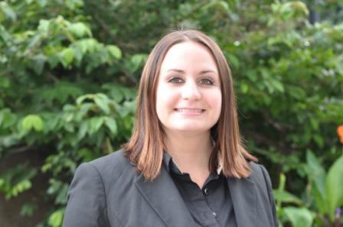
Amily Imbrogno - Publications Editor

Ami is a third-year student at Cleveland Marshall College of Law. She graduated cum laude from Malone University with a Bachelor of Arts in Political Science, where she won the third-place speaker award at a national debate tournament. She was also a part of the spring 2008 White House Internship program. Prior to law school, she worked in the wireless sales industry. Ami is currently the Treasurer of the C|M|LAWJustinian Forum, and is working as a law clerk for criminal defense attorney Robert Walton. She likes animals and enjoys long-distance running.

Monica Hupertz - Research Editor

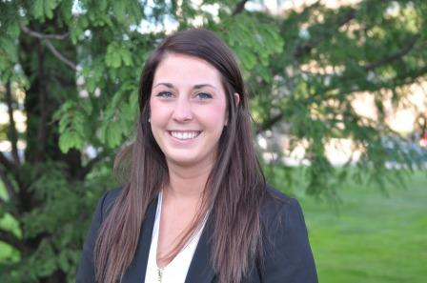
Monica Hupertz is a third-year law student at Cleveland-Marshall College of Law. She graduated from the University of Mount Union in 2011, where she studied Communications, focusing in Media Studies, and Business Administration. During her time at Mount Union, Monica was a four-year student-athlete participating in the volleyball program. During the senior year of her volleyball career, Monica received both Academic All-Conference and All-Conference Honorable Mention Athlete awards. Monica also was an on-air personality for the campus radio station, WRMU, and wrote for the college newspaper, The Dynamo. This past summer, Monica clerked for University Hospitals Legal Department located in Shaker Heights. Currently, Monica is a Legal Writing and Research Tutor for Professor May at Marshall.

Kathleen Fibbi - Research Editor

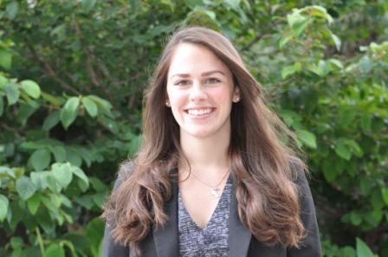
Kathleen Fibbi is a third year student at Cleveland-Marshall. She graduated cum laude from John Carroll University with a Bachelor of Arts in Sociology and a minor in History. While a student at John Carroll, Kathleen was a member of Phi Eta Sigma National Honor Society, volunteered with Labre and the West Side Catholic Center, and participated in a Border Awareness Program in Juarez, Mexico. Kathleen also interned at the Cuyahoga County Witness/Victim Service Center. This past summer, Kathleen worked in the legal department at Cleveland's Central Collection Agency, where she still works part time.

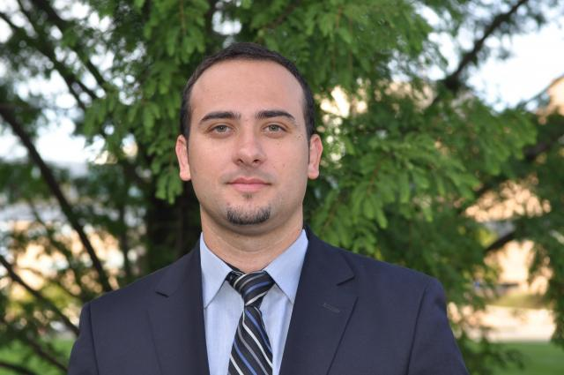
Sebastian Pascu - Articles Editor
Sebastian Pascu is a third-year student at Cleveland-Marshall. He graduated from The Lucian Blaga University, Romania, with a Bachelor of Arts. Sebastian was honored with a merit scholarship for the (2000–2004) academic year. While a student of Lucian Blaga, Sebastian was the Vice President of ASTRA (Transylvanian Association for Romanian Literature and Romanian Culture). Sebastian was an extern with the city of Lorain Law department last summer. Currently, he is employed as a law clerk for Alan Rosca. His work focuses on complex commercial and financial litigation and arbitration, particularly in the areas of securities and investment fraud. His Note, “Physician Assisted Suicide: Consideration For The Need Of Law Reform in Ohio” will be published in the Journal of Law and Health, Volume 27, Issue 2 (forthcoming Spring 2014).

William White - Articles Editor
William White will be graduating from Cleveland-Marshall in December 2013. William is currently attending Pitt Law as a visiting student, and plans to reside and work in Pittsburgh, where he met his wife. He graduated magna cum laude from Marian College, Indianapolis with a Bachelor of Arts in Psychology, and several years later graduated summa cum laude from Cleveland State University with a Bachelor of Arts in Social Work. William developed excellent advocacy and client skills while working as a social worker for thirteen years for a skilled nursing facility. Beginning the law program at Cleveland-Marshall as a night student, he transitioned to the day program, externed for the General Counsel at the Cleveland Clinic Foundation, and worked as a legal intern for Medical Mutual of Ohio over the summer. He was awarded the Barbara J. Tyler Award for Best Note and the Outstanding Associate Award in April 2013.

Caitlin Hill - Executive Editor
Caitlin Hill is a third-year law student at Cleveland-Marshall, and is also member of the Moot Court team. She graduated from Ohio State University in 2011 with undergraduate degrees in International Studies and Journalism. While at Ohio State, Caitlin was a member of the Ohio Union Activities Board and worked as a bookseller at the Student Book Exchange, one of OSU’s local student bookstores. Caitlin also volunteered for the Franklin County Democratic Party, and was a member of the Phi Sigma Pi academic honors fraternity.

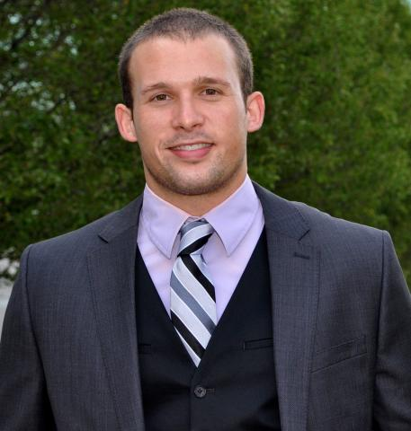

John Knauff - Executive Editor

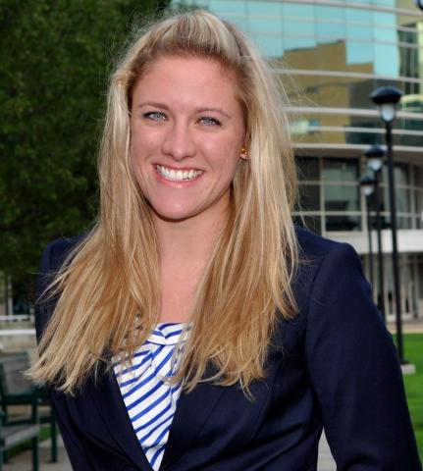
Katherine Riley - Executive Editor
KateLynn Riley is a third-year student at Cleveland-Marshall. She graduated cum laude with department honors from The College of Wooster with a Bachelor of Arts in History and minors in Communication and Political Science. While a student at The College of Wooster, KateLynn was a member of the Phi Alpha Theta National Honor Society and earned four varsity letters in volleyball and four varsity letters in track and field. At Wooster, KateLynn wrote her Senior Independent Study, "The Politics of Fashion," which looked at three First Ladies of the United States and what their fashions said about the country during their time in the White House. This past summer, KateLynn interned at the Riley Law Firm, a firm representing school districts in Ohio in Westlake, OH.

Gillian Steiger - Managing Editor
Gillian Steiger is a third-year student at Cleveland-Marshall. She graduated magna cum laude from John Carroll University. While a student at John Carroll, Gillian was involved in John Carroll's Literature Society, and volunteered with the University Heights School District and Cleveland Metropolitan School District as a tutor to middle school students and high school students. Gillian is currently clerking for Lazzaro Law Offices, a small plaintiff's firm specializing in personal injury, in Rocky River, Ohio. She is a member of C|M|LAW's Trial Advocacy Team, and is the C|M|Law Student Representative for CMBA's 3R's committee. Currently, Gillian is volunteering at Shaw High School for the 3R's for the second year in a row. Gillian is also the C|M|LAW student liaison for the Ohio State Bar Association.

Katherine Southworth - - Managing Editor
Kate Southworth is a fourth year part-time student at Cleveland-Marshall. After graduating from Magnificat High School, she earned a Bachelor of Arts degree with majors in Political Science and English from Baldwin-Wallace University. While at Baldwin-Wallace, Kate was awarded a Deans scholarship and served as an officer on the university's Publications Board. Kate earned a Master of Public Administration degree in Economic Development from the Maxine Goodman Levin College of Urban Affairs, where she was a member of Pi Alpha Alpha (the National Honor Society for Public Affairs). Kate is currently a Senior Investigator at Research Associates, Inc., a corporate investigative research firm located in Westlake, Ohio.

Antoinette Wall - Managing Editor
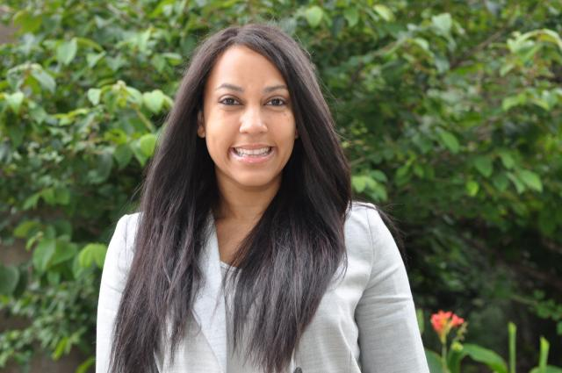
Antoinette Wall is a third-year part-time law student at Cleveland-Marshall College of Law. She graduated from The University of Akron with a B.A. in English. Ms. Wall has volunteered numerous hours to community service and community outreach throughout Ohio and Pennsylvania. She currently works at Akron Public Schools as a Substitute Teacher, was a 2013 Summer Associate at Hahn Loeser & Parks LLP, and has interned at The Law Office of Stephen P. Kocon, LLC. She is also an active member of Cleveland-Marshall College of Law’s Black Law Students Association.

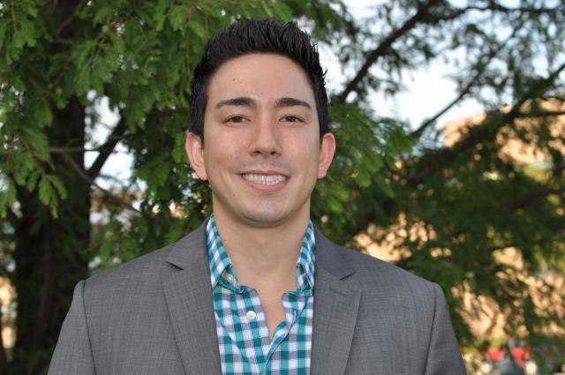
Michael Callam - Business Editor
Michael Callam is a third-year student at Cleveland-Marhsall. He graduated from The Ohio State University with a Bachelor of Science in Business Administration with a concentration in Finance. Michael is the president of the Asian Pacific Islander Law Students Association and vice president of the Criminal Law Society. Prior to law school, Michael worked as an financial advisor and started a restaurant in Chesterland, Ohio. Michael spent last summer interning for the Office of General Counsel for Cleveland State.

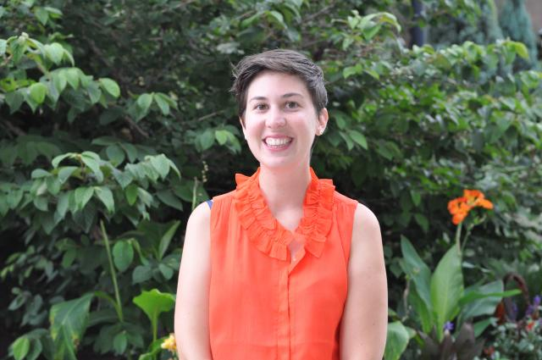
Kathleen Laraway - Technology Editor
Kate is a third year student at Cleveland-Marshall College of Law. She graduated cum laude from The Ohio State University with a Bachelor of Arts in English literature and Spanish language. Before law school, Kate served for a year with AmeriCorps as a City Year Cleveland Corps Member. She spent the summer after her first year of law school as a summer associate at Legal Aid working in the Community Advocacy Program and has externed with the Honorable Patricia A. Gaughan for the Northern District of Ohio. Kate spends her time outside of law school working as a freelance copywriter for a local digital marketing agency and exploring Cleveland with her dog, Olive.

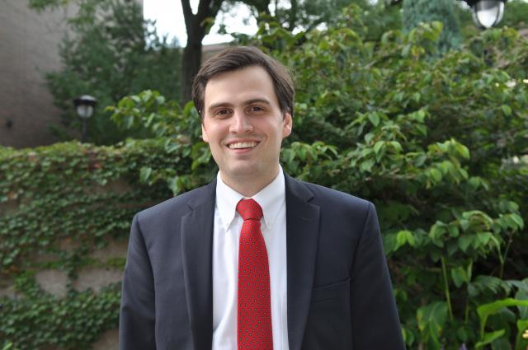
Gordon Gantt, Jr. - Symposium Editor
Gordon Gantt is a third-year law student at Cleveland-Marshall. Gordon is the Symposium Editor for the Journal of Law & Health, a member of the Hispanic Law Student Association, and a member of the C-M Law Moot Court team. Gordon's note "Hacking Healthcare: Authentication Security in the Age of Meaningful Use" will be published in an upcoming issue of the Journal of Law & Health. A native of North Carolina, Gordon earned a bachelor's degree in Journalism, with honors, from the Ohio State University. He is married and lives with his wife in the West Park neighborhood of Cleveland.

