Investigative Research: Public Records and “Publicly Available Information
by Sue Altmeyer
for the National Business Institute Program, “Finding it Free and Fast on the Net: Strategies for Legal Research on the Web”

Outline
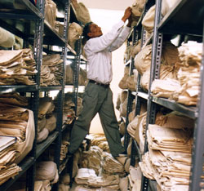
- Accessing Public Records
1. What are Public Records?
2. Restrictions on Accessing Public Records
a. Driver’s Privacy Protection Act
b. Fair Credit Reporting Act
c. Social Security Number Protection Legislation
d. Gramm Leach Bliley
3. Hints for Public Records Research
4. Portals
- Professional Licenses and Disciplinary Actions
1. Generally – Ohio
2. Generally – Other States
3. Attorneys
4. Doctors
5. Stock Brokers/Financial Planners
6. Accountants.
- Criminal Records
- Vital Statistics:
1. Birth & Death
2. Marriage & Divorce

- Real and Personal Property Records
1. Real Property
2. Airplanes
3. Boats
4. Automobiles
5. Stocks
6. UCC Filings
7. Judgments & Liens
8. Unclaimed Funds

A. Accessing Public Records

1. What are Public Records?

Ohio- Not all government records are public records under Ohio law. Public records may be accessed for the most part, without restriction. For state records, a public record is defined by ORC 149.43. Some of the items excluded from the definition of public records are: medical records, probation records, adoption records and confidential law enforcement records.
For more information, see Public Records Law in Ohio, http://www.lsc.state.oh.us/membersonly/127publicrecordslaw.pdf, an Ohio Legislative Service "Members Only" Brief, Oct. 23, 2008 and Ohio Attorney General - Ohio Sunshine Laws, http://www.ag.state.oh.us/legal/sunshine.asp.
Federal – The Freedom of Information Act (FOIA) also has categories of information that will not be disclosed. For example, national defense information, personal and medical information, ongoing law enforcement investigations and confidential sources, certain geological information and information exempt under federal law. See 5 USC 552(b).
For more information on the federal Freedom of Information Act and Ohio public records law, see Cleveland Law Library's Public Records FAQ, http://www.clelaw.lib.oh.us/Public/Misc/FAQs/Public_Records.html.

2. Restrictions on accessing public records?
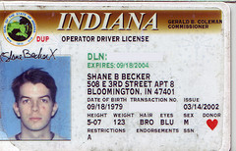
The government or a purchaser and distributor of government information may be subject to certain laws prohibiting distribution of the information unless there is a permissible use.
a. Driver’s Privacy Protection Act, 18 USC 2721 allows access to driver’s license, title and registration information for certain purposes. Under the Driver’s Privacy Protection Act, use in connection with a civil or criminal case is a permissible use.
Image: 'My Second Driver's License'
www.flickr.com/photos/15914631@
N00/3348033929

b. Fair Credit Reporting Act, 15 USC 1681 et seq.
Requires that a “consumer report” gathered by anyone regularly involved in the business of compiling and selling consumer reports (“consumer reporting agency”) can only be disclosed to those who have a permissible use.
i. What is a "consumer report"?
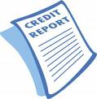
“… any written, oral, or other communication of any information by a consumer reporting agency bearing on a consumer's credit worthiness, credit standing, credit capacity, character, general reputation, personal characteristics, or mode of living which is used or expected to be used or collected in whole or in part for the purpose of serving as a factor in establishing the consumer's eligibility for--
(A) credit or insurance to be used primarily for personal, family, or household purposes;
(B) employment purposes; or
(C) any other purpose authorized under section 1681b of this title.”
15 U.S.C.A. § 1681a.
Consumer reports include more than credit reports. They include "anything that impacts general reputation", such as criminal and civil court records, driving records and more.
If the information was originally collected for purposes of credit eligibility, insurance, employment or licensing AND/OR the report is used or expected to be used for credit eligibility, insurance, employment or licensing, the report falls under the Act. If the report was not created or used for these purposes, or expected to be used for these purposes, it is outside the FCRA.
Cases:
- Under the FCRA whether a credit report is a consumer report does not depend solely upon the ultimate use to which the information contained therein is put, but instead, it is governed by the purpose for which the information was originally collected in whole or in part by the consumer reporting agency. St. Paul Guardian, 884 F.2d at 883-84.
- Credit reports on a dentist and his daughters were “consumer reports” within meaning of FCRA, regardless of attorney's intended use of the credit reports. Bakker v. McKinnon 152 F.3d 1007, 1012 (C.A.8 (Ark.),1998)
- Where, in suit against credit-reporting service for alleged violations of Fair Credit Reporting Act, it appeared that credit report was prepared for use in connection with state court civil action in which individual defendant was seeking to increase child support and medical expenses to be paid by plaintiff, such report was not “consumer report” within meaning of Act . Gardner v. Investigators, Inc. 413 F.Supp. 780 (D.C.Fla. 1976).
ii. Is a lawsuit a permissible purpose?
While a lawsuit occasionally may give rise to a “legitimate business need” for a consumer report, see Spence v. TRW, Inc., 92 F.3d 380 (6th Cir.1996), trial preparation generally does not fall within the scope of § 1681b. See Mone, 945 F.2d at 308; Houghton, 795 F.2d at 1149; see also Allen v. Calvo 832 F.Supp. 301, 303 (D.Or.1993), Duncan v. Handmaker 149 F.3d 424, 427 (C.A.6 (Ky.),1998).
iii. What is a consumer reporting agency?

Consumer reporting agencies include Westlaw, Lexis, Accurint and OpenOnline because they are in the business of buying and selling consumer reports. Open Online requires you to select a permissible purpose, while the Lexis and Westlaw descriptions of databases, such as Lexis Smartlinx, contain warnings that the information must be used for a permissible purpose.
iv. Use for employment purposes: The Fair Credit Reporting Act imposes restrictions when the consumer report is used for employment purposes. The employee/potential employee must agree in writing that the employer/potential employer can have access to the consumer report. If the employer/potential employer takes an adverse action as a result of the consumer report, the employee/potential employee must be notified. 15 U.S.C. 1681b.
When searching public records via a “consumer reporting agency” such as Westlaw, Lexis, Accurint or OpenOnline, the Fair Credit Reporting Act applies. If an employer conducts a search of a government database on the Internet for the same information, the restrictions of the Fair Credit Reporting Act do not apply.
For more information on the Fair Credit Reporting Act, see Federal Trade Commission: Facts for Businesses, http://www.ftc.gov/bcp/edu/pubs/business/credit/bus08.shtm.
Also See: Attorney Liability Under the FCRA: The Limits of Zealous Representation, T. Leigh Anenson, 23 Ann. Rev. Banking & Fin. L. 431 (2004) via Westlaw.; 1-10 Anderson's Ohio Consumer Law § 10.4; 1-16 Consumer Credit Law Manual § 16.02.

c. Social Security Number protection legislation:
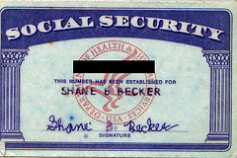
Besides the threat of being sued for negligence, is there any Ohio or Federal legislation prohibiting the disclosure of social security numbers?
- Intelligence Reform and Terrorism Prevention Act of 2004 (Can not put social security number on driver’s license) 42 U.S.C.A. §405c(2)C(vi)(II)
- Ohio S.B. 6 prohibits a public office from making available to the general public on the Internet any document that contains an individual's Social Security number. (R.C. 149.45(B)(1) and (2))
Image: 'My First Social Security Card'
www.flickr.com/photos/15914631@
N00/3348033925
- Legislation has been introduced in the U.S. Congress in recent years to prohibit the commercial sale of SSNs. The latest version is the Protecting the Privacy of Social Security Numbers Act of 2009, HR 122 and S. 141. (Use the search feature in http://thomas.loc.gov/ to locate this bill.) These bills contain an exceptions, including an exception for employee background checks. See Privacy Rights Clearinghouse, My Social Security Number: How Secure is It?

d. Gramm Leach Bliley 15 USC §§ 6801-6809, also 16 CFR Part 313.01, esp. 313.14, 313.15.
If a compiler of records such as Lexis or Westlaw obtains information from credit bureaus or other "financial institutions", there must be compliance with the Gramm Leach Bliley Act. Financial institutions include anyone who lends money. GLB applies to non-public personal information.
"This type of information is contained in the credit header data LexisNexis and its competitors receive from the credit bureaus." Some (ex ALLFIND) but not all of the Lexis person finder database contain this information. Lexis will ask you to select a permissible purpose before using the database. See What You Should Know About LexisNexis Person Locator Products and the Gramm Leach Bliley Act - http://www.lexis-nexis.com/clients/fbi/-GLBA.pdf. The end user of the information (ie. the researcher, you) must have a permissible purpose for the information.
Some possible permissible purposes may include due diligence research, insurance claims investigations, asset verification to prevent fraud or for consumer collections, locating beneficiaries and heirs to prevent fraud or if acting in a fiduciary capacity, locating customers for legal purposes, child support enforcement, acting in a fiduciary capacity to locate shareholders or pension beneficiaries, collection activities, skip tracing to locate debtors. (this is a general summary and is not legal advice) See What You Should Know About LexisNexis Person Locator Products and the Gramm Leach Bliley Act
INTERESTED IN MORE ABOUT PUBLIC RECORDS LAW? Check out the Privacy and Security Data Law Journal, which started publication in 2006

3. Hints for Public Records Research

- Is it possible to do a comprehensive online background check for free? Probably not. The free materials available on-line are generally discrete bits of information – from one court or agency, whereas pay services will search many databases at once. There are some free online databases which allow searching across states, such as criminalsearches.com, but these may not contain data from every court or every county. Additionally, not every court or government agency makes records available on the web.
- What are some good for-fee databases? Lexis and Westlaw are good, but can be expensive. Accurint, OpenOnline, Mergent, Choicepoint and KnowX are reputable services that usually cost less. 1800US Search.com, NetDetective.net, SearchSystems.com are also said to be reputable.
- When using information from fee services, cross-check the information among multiple databases or websites to ensure accuracy. When using ANY public records providers, it is a good idea to double check the information with another service for accuracy. Information in a database may lack currency or suffer from data entry errors.
- Check the coverage of the database. How far does it go back? What states or counties are included?

4. Portals
Portals provide links organized by state, county and/or type of public record. Some of these will provide limited information for free, and further information for a fee.
- Cleveland Marshall College of Law Library - Public Records Research Guide - http://www.law.csuohio.edu/lawlibrary/resources/lawpubs/publicrecords/index.html - Links to free sites, and public records available via law school Lexis and Westlaw accounts.
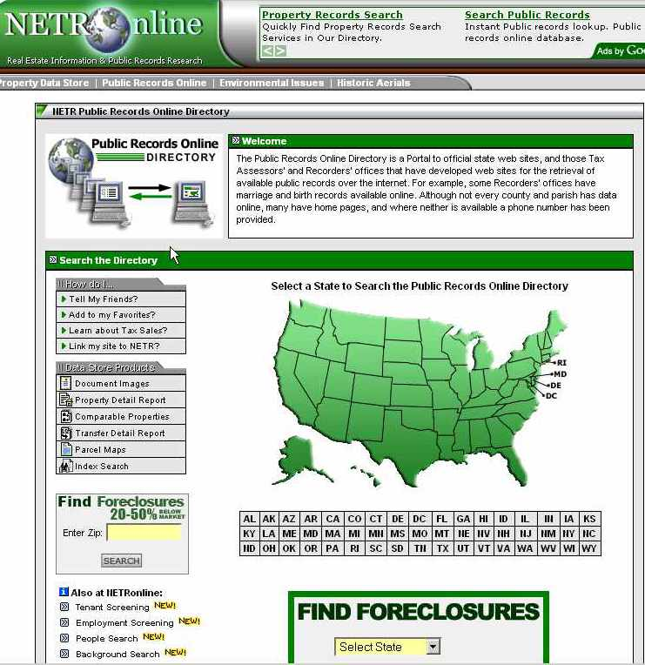
- BRB Publications: Links to free sites, arranged by jurisdiction. Contains links and hints for finding motor vehicle records.
- Netronline: Contains public records links for the fifty states, broken down by county. Offers people searches and background checks for a fee.
- Searchsystems.net: Contains a search engine to locate the desired type of public record. Links are arranged by type of public record and by state and Canadian province.
- PublicRecords.com: (also see http://publicrecords.onlinesearches.com) has a free people finder search that will give cities and state of residence, age and possible relatives. There is a fee for other information.

Lots more portal links via the Cleveland Law Library’s Public Records FAQ - Portals.

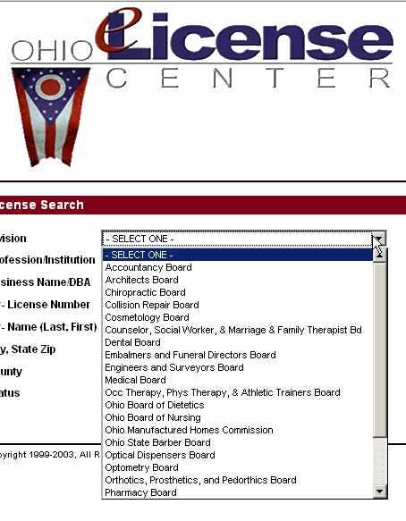
B. Professional Licenses
Professional license information can reveal a person’s business address, whether they are currently licensed and whether they have been subject to disciplinary action by the governing bodies of their profession. Below find links for license look-ups in the 50 states, as well as information concerning attorneys, doctors, stock brokers and accountants.
1. Ohio License Center - https://license.ohio.gov/lookup/default.asp -
Obtain license information for numerous professions in Ohio. Search by name, license number or business name.
2. Other States:
Use Search Systems.net to find license look-ups for other states or use Lexis - Public Records>Find Licenses.
3. Attorneys
License Lookups:
- A Compilation of State Lawyer Licensing Databases - http://www.llrx.com/features/lawyerlicenses.htm
- Ohio Supreme Court – Attorney Information Search - Includes attorneys who have been admitted to the practice of law in Ohio and directory does not necessarily indicate that the attorney is in good standing.
- Daily Legal News: Find out if a lawyer is licensed in Ohio.
Disciplinary Actions against Attorneys:
- Ohio Supreme Court: Attorney Information Search. Does not indicate whether the person has been sanctioned by the Supreme Court pursuant to Gov. Bar R. VI (registration & registration fee) or Gov. Bar R. X (continuing legal education).
- Ohio Supreme Court cases on the web back to 1993, can be searched for disciplinary cases.
- ABA - Directory of Lawyer Disciplinary Agencies - http://www.abanet.org/cpr/regulation/directory.pdf
- National Lawyer Regulatory Databank - http://www.abanet.org/cpr/regulation/databank.html - Searches nationwide for disciplinary actions against an attorney for a fee.
4. Physicians
- Doc Finder – http://www.docboard.org/docfinder.html - Links to State Medical Boards which have directories of physicians licensed in that state.
Disciplinary Actions
- Doc Finder
- Public Citizen –http://www.citizen.org/hrg/forms/medicalboards/2006/medicalboard.cfm - Links to doctor disciplinary information on state websites.
- Ohio Medical Board Disciplinary Actions - http://med.ohio.gov/lookupinstructions.htm


5. Stock Brokers
- SEC - Check Out Brokers and Advisors –http://www.sec.gov/investor/brokers.htm- Links for finding out whether investment professionals are licensed by the state or federal government and whether they have had run-ins with regulators or serious complaints from investors. Information on firms and brokers. Links to the SEC - Investment Advisor Search.
- FINRA Broker Check -http://www.finra.org/Investors/ToolsCalculators/BrokerCheck/index.htm - Check the professional background of current and former FINRA-registered securities firms and brokers. FINRA is a non-government regulator of securities firms.
- Certified Financial Planner Look-up – http://www.cfp.net/search/ - Find financial planners certified by the Certified Financial Planner Board of Standards, Inc. and whether there has been disciplinary action by the Board. This database DOES NOT indicate whether the planner holds required federal or state licenses.
- National Futures Association's Background Affiliation Status Information Center (BASIC). - http://www.nfa.futures.org/basicnet/
- Ohio Department of Commerce: Securities Division: http://www.securities.state.oh.us/about/FAQpage.aspx - This FAQ discusses obtaining information on brokers from the state.

6. Accountants
- AICPA - State Boards of Accountancy, http://www.aicpa.org/yellow/ypsboa.htm for licensed accountants and disciplinary actions in each state.
- AICPA Disciplinary Actions - http://www.aicpa.org/Professional+Resources/Professional+Ethics+Code+of+Professional+Conduct/Disciplinary+Actions
- Accountancy Board of Ohio - Contains links to Ohio License Center for current licensing status of individual CPAs and firms. Also has information on disciplinary actions – http://acc.ohio.gov/dhearing.htm.


C. Criminal Records
General Points:
- So-called "national" databases are inaccessible to non-governmental users. See “National Criminal Background Checks: Myths, Realities & Resources” by Jackie Walters.
- For both commercial and free databases, check the coverage. So called comprehensive databases may not include misdemeanors, may include convictions and not arrests, may include only offenses where a person received jail time etc.
Image: 'new jack city'
www.flickr.com/photos/73197296@N00/382088627
- Start with the broadest possible database you can afford, then fill in any gaps by searching individual courts or sheriff’s offices in jurisdictions where the person was active.
Methods for finding criminal records:
1. Visiting the Sheriff’s Office in Person: Cuyahoga County felony arrest records can be obtained at the County Sheriff’s office. Records cost $6.00 and go back to the early 1970s. For misdemeanors, check with municipal courts or police departments. To find other Ohio Sheriff’s departments: www.buckeyesheriffs.org.
2. Docket searches of individual courts – See Cleveland Marshall College of Law Library Resource Guides - Resources for Online Court Dockets - http://www.law.csuohio.edu/lawlibrary/resources/lawpubs/ResourcesforOnlineCourtDockets.html.
3. Pay databases– LexisNexis, Westlaw, Openonline and Accurint enable searching over many jurisdictions at once. They may not pick up misdemeanors or all arrests. Examine the scope of database before paying to search.
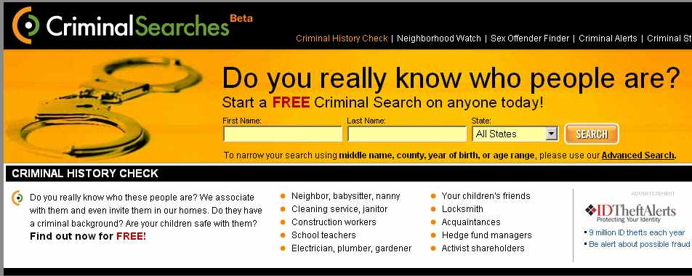
4. Free Internet Databases
Criminalsearches.com: Searches across numerous states and counties. Currently does not include all courts/counties.

- Federal Bureau of Prisons - www.bop.gov/iloc2/LocateInmate.jsp Information on federal prisoners incarcerated 1982 to present.
- Ohio Department of Corrections - http://www.drc.state.oh.us/OffenderSearch/Search.aspx - Offenders sentenced to serve time in a STATE facility.
- Corrections.com – Links to other states’ databases.
- Policereports.us - Find actual copies of police reports. Unfortunately, few Ohio cities provide police reports via this database.
- Sex offender databases:
- National Sex Offender Public Registry: http://www.nsopw.gov Search for names of sex offenders in multiple state databases at once. Search by locality or zip code.
- FBI's State Sex Offender Registries: http://www.fbi.gov/hq/cid/cac/registry.htm - Links to state sex offender databases.
- Family Watchdog - http://familywatchdog.us/ - Find offenders nationwide by street or offender name.
Other ideas:
- Phoenix Research - http://www.hrliability.com - charges $6-7 per county for an on-site criminal records check.
- Ohio Attorney General’s Office WebCheck: http://www.ag.state.oh.us/business/fingerprint/index.asp - Upon the request of a person whose background is being checked, the check will be performed for a fee. Fingerprints must be submitted. Reveals arrests for felonies and escalating misdemeanors. Escalating misdemeanor means any offense classified as a misdemeanor on the first offense and a felony on subsequent offenses.
- The concealed carry list may be a way to clear people, as one must have no misdemeanors of violence. - http://sheriff.cuyahogacounty.us/ccw.asp. The list must inspected in person and can not be copied. R.C. 2923.129(B)(2)(a). Also, you need to be a journalist to access!
- Online dockets – only yields results if the defendant is indicted. Check Pacer (federal) and state court dockets. KnowX can search multiple dockets at once in 49 states for only 2.95. It costs more to retrieve a docket record - $7.95 for one, $19.95 for multiple records. You can always do the search, and then go to the court’s website and look at the docket for free.
- Newspapers – America's Newspapers: Newsbank and many more available at the Cleveland Marshall College of Law Library or online via the Cleveland Public Library. Voyager - http://www.newspaperlinks.com/voyager.cfm -provides links to free newspapers on the web. Lexis (ALLNWS or other) or Westlaw (ALLNEWS or other) also available.


D. Vital Statistics

1. Birth & Death Records
Vital Records are typically maintained by the state health department, but older records may be kept by a historical society. In Ohio the Ohio Department of Health – http://www.odh.ohio.gov/vitalstatistics/vitalstats.aspx has recent certificates, 1945 and later. Order online or find the location of local offices where you can obtain copies. For example, Cleveland City Hall is one such local office.
The Ohio Historical Society, Death Certificate Index –http://ohsweb.ohiohistory.org/death has information about deaths from 1913-1944: Search the index and order certificates by mail. The Ohio Historical Society also has some birth records from certain probate courts for 1867-1908, but they are not online. See the Historical Society’s page: About Birth Records in Ohio - http://www.ohiohistory.org/resource/archlib/brthdth1.html.
To obtain vital records for the fifty states, contact the National Center for Health Statistics - http://www.cdc.gov/nchs/w2w.htm

Death Records - More sources:

Cleveland area:
For obituaries and cemetery records from 1850- 1975, see the Cleveland Necrology File. It can be accessed online via Cleveland Public Library research databases - http://www.cpl.org/index.php?q=node/102. For obituaries 1976-present, try the Cleveland News Index via Cleveland Public Library research databases. For Plain Dealer death notices and guest books for the past 180 days, see http://www.legacy.com/Cleveland/DeathNotices.asp.
Nationwide:
Try obituary searches, such as America’s Obituary and Death Notices via the Clevland Public Library. At Cleveland State, try America's Newspapers: Newsbank or America's Historical Newspapers (Newsbank) via Ohiolink and select type=obituary. Westlaw has a database called Obituary Pages, with information from U.S. and International papers. Lexis has a database called Obituary Information, which covers various news sources from 1993.
A commercial site, the National Obituary Archive - http://www.arrangeonline.com – obtains death information from funeral homes. Relatives and friends can attach tributes, which can be made permanent for a fee. Guest books are attached permanently for free.
There are two directories to obituary sites on the web: Obituary Central , http://www.obitcentral.com, a directory of obituary sites and Online Searchable Death Indexes –http://www.deathindexes.com. The later links to death records, death certificate indexes, death notices & registers, probate indexes, and cemetery & burial records for the fifty states, as well as obituaries.
The Social Security Death Index, via Rootsweb, will tell you the dates of birth, death and last known address for deaths filed with the Social Security Administration 1963 and later. Westlaw has a SSA Death Records database, which is the same as the Social Security Death Index on the web.


2. Marriage and Divorce Records
Abstracts can be ordered from Ohio Department of Health - http://www.odh.ohio.gov/vitalstatistics/vitalstats.aspx . The Ohio Department of Health requests that you provide the name of the bride/groom, years in which to search, and the city where the marriage/divorce took place. You at least have to know the county where the marriage/divorce took place. If you do not know the county, commercial databases come in handy.
Newspaper databases may come in handy when you do not know the city or county where the marriage/divorce took place. Lexis (ALLNWS or other), Westlaw (ALLNEWS or other) , America's Newspapers: Newsbank and many more databases are available at Cleveland Marshall and available via the Cleveland Public Library.
For marriage license information specific to Cuyahoga County, see Cuyahoga County Probate Court Marriage License Index - http://probate.cuyahogacounty.us/ml/ covering marriages from 1810 to April 1998. Marriage License records from April 6, 1998 to the present are provided in the Search Docket and Index system - http://probate.cuyahogacounty.us/ml/pa.urd/pamw6500.
Actual copies of marriage licenses must be obtained from the probate court of the county in which the marriage took place.
Actual copies of divorce decrees must be obtained from the domestic relations court. If the court has an online docket, it may help confirm that a divorce took place in that county. For example, see the Cuyahoga County Domestic Relations Court Docket - http://cpdocket.cp.cuyahogacounty.us/TOS.aspx . If you don’t know where a divorce took place, commercial databases may help. Lexis has marriage and divorce records for 15 states, including Ohio. Lexis -Public Records>Find Filings>Marriage & Divorce Records. Westlaw has divorce records for 12 states - Public Information, Records & Filings>Litigation & Court Records>Divorce Records by State.

E. Real and Personal Property Records

General Hints:
- Check recent divorce filings.
- Typically easier on a for-fee database that will allow searching across counties and states, such as Lexis, Westlaw or Accurint .
- Portico - http://indorgs.virginia.edu/portico/personalproperty.html - provides state-by-state links for real estate, aircraft and boats.

1. Real Property
National: Check the County Recorder’s office for deeds, mortgages and liens. The deed will indicate the selling price for the property. Check the County Auditor’s office for current property ownership, taxable value and property description. To find county recorders nationally, try Portico . For finding county auditors nationwide, try Property Assessment Databases - http://homepage.mac.com/researchventures . Take a look at zillow.com for a national database of real estate sales listings. One can search Zillow by address, street or city.
Ohio: Find recorders’ offices in each Ohio county via the Butler County Clerk Statewide Property Search – http://www.butlercountyclerk.org/ . The Butler County Clerk also provides links to Ohio county auditors' offices via the Statewide Real Estate Tax Search .

Cuyahoga County:
- Cuyahoga Enterprise Geographic Information System (CEGIS) - http://gis.cuyahogacounty.us has detailed information on houses and businesses in the county. The system combines information from the Cuyahoga County Auditor's Office and Recorder's Office. It will show the property owner, liens, how much was paid for the house, whether taxes have been paid and a detailed deed transfer history. A map shows information about the property's neighborhood - census information, nearby sex offenders, nearby foreclosures and more. The site is free with registration.
- Foreclosure Sales – http://sheriff.cuyahogacounty.us/propertysearch.asp - Search for foreclosed properties that have been sold to find the sale amount and purchaser. See Bulletins for sale listings.
- Neo Cando – http://neocando.case.edu- A service of Case Western University, this site provides property, tax and transfer information for properties in Northeast Ohio. Requires free registration. Enables mapping of neighborhoods or census tracts based on property characteristics.

2. Airplanes

Search by owner name for Aircraft registrations (A/C Registrations) in the United States and foreign countries via Landings - http://www.landings.com . Portico - http://indorgs.virginia.edu/portico/personalproperty.html provides links including the FAA Registry and sites for buying and selling aircraft. Lexis and Westlaw also have aircraft databases. Lexis has bluebook and valuation databases for aircrafts as well.

3. Boats
Boats are registered and titled by state. For Ohio, the Ohio Department of Public Safety Online Vehicle/Watercraft Title Inquiry - http://www.dps.state.oh.us/atps/titleinq.asp?mode=i allows a search by title number or VIN number only. Owner name searches are possible on Documented Vessels - http://publicrecords.onlinesearches.com/documented-vessel-database.htm for all US Coast Guard registered vessels. Name searches can also be performed on Lexis, Westlaw and KnowX. Portico has some links to sites where boats are bought and sold.

4. Automobiles
Similar to boats, the Ohio Department of Public Safety Online Vehicle/Watercraft Title Inquiry only allows a search by title number or VIN number of a motor vehicle. To search for vehicle owners by name, a pay service such as Lexis, Westlaw or OPENonline must be used. There must be a permissible purpose under the Driver’s Privacy Protection Act, 18 USC 2721.

5. Stocks
Stock ownership for corporate insiders – officers, directors and shareholders owning more than 10% of a single class of stock – can be discovered via databases containing SEC Forms 3, 4, 5 and 144. Form 3 is the initial statement identifying the holdings of insiders, Form 4 show amendments, Form 5 is an annual form and Form 144 is a notice of proposed sale of restricted securities, or securities held by an affiliate of the issuer. Try the Securities Exchange Commission’s Edgar/IDEA database - http://idea.sec.gov/ and search by form number and enter the person’s name in the full text search field. For-fee databases with the same information, but fancier search mechanisms, include Lexis - Stock Information and Westlaw- Insider Stock Transactions.

6. UCC Filings
UCC Filings can be found on the Secretary of State’s website. See the Ohio Secretary of State - http://www.sos.state.oh.us/UniformCommercialCode.aspx and click on Uniform Commercial Code – Search Filings (on the lefthand side). For links to Secretary of State offices in all fifty states, try the National Association of Secretaries of State – http://www.nass.org/ and click on “Secretaries of State.” Some UCC Article 9 filings may be with county recorder. Lexis and Westlaw both have UCC filings databases which enable searching all states at once.

7. Judgements and Lien Filings
The County Recorders' office will show liens on property (see real estate section, above). Westlaw and Lexis have judgment and lien databases.

8. Unclaimed Funds
Check the County Auditor's office or County Treasurer's office. For Cuyahoga County, check the Treasurer's office. Funds held by county and local governments are transferred to the Ohio Department of Commerce after five years. Ohio Revised Code 9.39. The Ohio Department of Commerce Online Treasure Hunt - http://www.com.state.oh.us/unfd/treasurehunt.asp - is an online search for unclaimed funds held by the Ohio Department of Commerce. For more information, see the Ohio Department of Commerce, Division of Unclaimed Funds - http://www.com.ohio.gov/unfd.
For links to government offices holding unclaimed funds and information about recovering funds in the 50 states, see National Association of Unclaimed Property Administrators . For information on unclaimed funds held by the federal government, see U.S Treasury Department page: Unclaimed Money and Assets - http://fms.treas.gov/faq/unclaimed.html. To recover money from a failed financial institution, go to FDIC Unclaimed Funds - http://www2.fdic.gov/funds/index.asp. Westlaw has an unclaimed funds database.

