How Newly Enacted Federal Laws are Published:

The USA Patriot Act changed various titles of the U.S. Code, including the ones listed below.

USA Patriot Act
Pub.L. 107-56

Public Laws in USCCAN

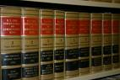

Arranged Chronologically – as the laws are enacted.
U.S. Code -
Arranged by Subject

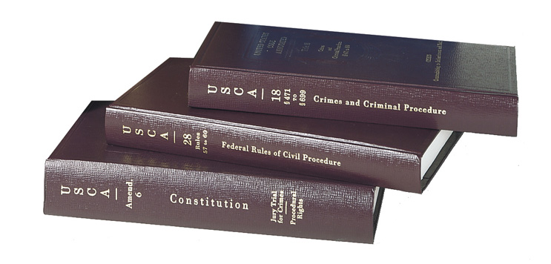

Title 8 – Aliens & Nationality
Title 12- Banking
Title 15 – Commerce & Trade

Title 18 - Crimes
Title 31 – Money & Finance
Title 42 – Public Health & Welfare
Title 47 – Telegraphs, Telephones, Radiotelegraphs
Title 49 – Transportation
Title 50 – War & National Defense

