
Firefox add-ons for Law Librarians

Presenter: Sue Altmeyer

Cite Genie


Creates Bluebook citations and adds pinpoint citation when you highlight a passage of text.

Highlight the text, right click and select Copy with Cite Genie.

Select Bluebook format or format for a particular jurisdiction from your browser’s Add on Manager. (If your jurisdiction has changed citation formats recently be sure to double check. Cite Genie has not adopted 1/1/12 Ohio Writing Manual changes.)

Works in:

Platform | Works? | Comments
Classic Westlaw | Yes
WestlawNext | Yes | Useful if Westlaw next does not yet provide citations for your jurisdiction
Lexis | Yes | If Lexis is run through EZ proxy, may not work
LexisAdvance | Yes | If Lexis is run through EZ proxy, may not work
Google Scholar | Bluebook only
Bloomberg Law | Bluebook only
Casemaker | Just gives url to document

Free for 90 days, then $14.97 for 3 computers.

If you upgrade Firefox and CiteGenie is reported as not compatible, try the latest beta version of CiteGenie.

http://citegenie.com/download.html

Fireshot
Screenshot creator with an annotation tool and crop tool.

Capture the visible area, entire page or area selected.

Allows saving and quick sharing of screenshots to Facebook, Flickr, etc.

Can integrate into Chrome and Internet Explorer

Insert images and make other edits.

Basic version is free.

http://screenshot-program.com/fireshot/

Jureeka
Has two features:
(1) A toolbar for retrieving cases, statutes and regulations on the free web; and (2) creates links to legal authority on a web page.

Jureeka toolbar:
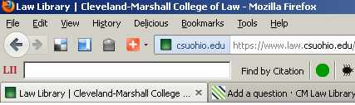

A partial list of covered citations is at the Jureeka Blog.

Also works for Chrome

Powered by Legal Information Institute (LII)

Example of Jureeka inserting legal citation links into html document:

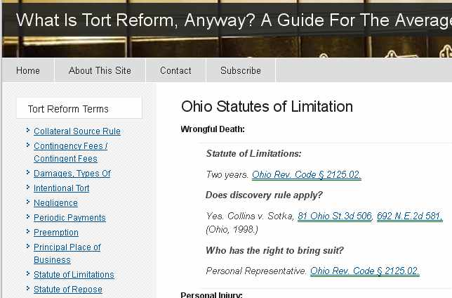

http://www.law.cornell.edu/jureeka_plugin

Recap


When you (or other Recap users) upload a document from PACER, it puts the document in a free archive, so other Recap users can access it for free.

When you go on to a PACER docket, the blue R icon will appear by the document number if that document is contained in the free RECAP archive. Click on the RECAP blue R icon to download the document for free.

Searchable archive available.

https://www.recapthelaw.org/about/

